**LEBANESE AMERICAN UNIVERSITY**

**USAID – HIGHER EDUCATION SCHOLARSHIP PROGRAM**

**HES - Volunteering Program Verification Form**

This form is to be used to document volunteering hours. If a student volunteers for multiple organizations, a separate form must be used for each organization. **This form must be turned in by the 28th of each month, the latest.**

I certify that the scholar Razan Ghrayeb completed a total of 5 hours of service at InnovaThrive.

The hours were completed hours as per the below:

Hours # 5 (date) _2/12 – 6/12_ (initials of supervisor) __A.K.___

Hours # 0 (date) _9/12 – 13/12_ (initials of supervisor) __A.K.___

Hours # 0 date) _16/12 – 20/12 (initials of supervisor) __A.K.___

Hours # 0 date) _23/12 - 27/12 (initials of supervisor) __A.K.___

Brief description of the activities the scholar performed or participated in:

I conducted a research task on The Psychology of Virtual Reality (VR) Therapy. The research explored how VR is being utilized in therapy to treat various psychological conditions, including PTSD, anxiety, and phobias. I examined the benefits of VR therapy, such as its ability to create immersive environments that help patients confront their fears in a controlled setting. Additionally, I discussed its drawbacks, such as the high cost of equipment and the potential for over-dependence on technology. I also explored future research directions, including the integration of VR with other therapeutic modalities and its potential for broader mental health applications.

Written feedback about the scholar’s performance:

Razan Ghrayeb’s research on VR therapy provided a compelling analysis of how this technology is transforming psychological treatment. Her examination of VR applications in treating PTSD, anxiety, and phobias was insightful. By addressing the benefits and drawbacks, such as cost and potential over-dependence, Razan demonstrated a balanced understanding of VR therapy's potential and limitations.

Please rate the overall performance of the scholar at your organization:

|  |  |  |  |
| --- | --- | --- | --- |
|  | Mastery (5) | Proficient (3) | Emerging (1) |
| **Problem solver** | X |  |  |
| **Engaged & Committed** | X |  |  |
| **Open-minded & multicultural** | X |  |  |

Signature

& stamp

__________________________

_

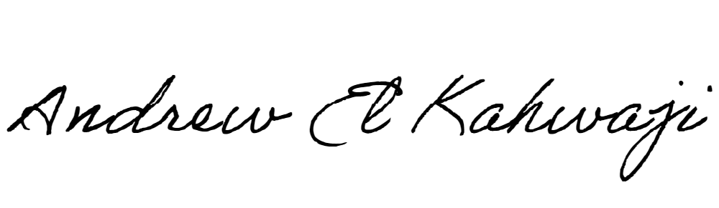

Printed Name _Andrew El Kahwaji_

Date __26/12/2024___

Email __andrew.lifesculptor.coo@gmail.com __

Phone __+961 71 914 378__